Access to Services Journal Tip Sheet
*Please note that the Access to Services Journal is only completed for clients who are offered an appointment. It is completed whether or not they end up scheduling an appointment. For clients who merely request information, no action is necessary in the Access to Services Journal.
- Open the Access to Services Journal
  - Select the Systems Button Menu ATP Access to Services Journal
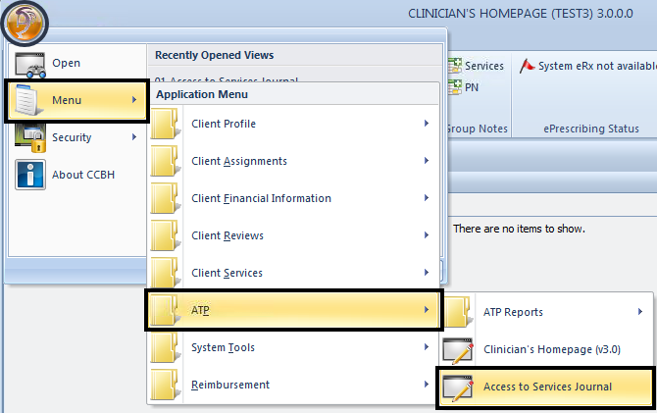
- The date and time of the contact will pre-populate to the date and time that the Access to Services Journal was launched. Adjust the date and time to reflect the first date and time of contact with the client. Administrative staff who transfer data from the log must match the date and time with the original date of contact on the log. Enter the Unit and SubUnit.
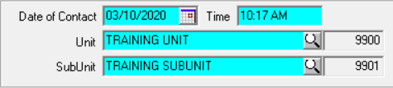
- Enter Contact Type (the method by which the program was contacted), Contact Reason, and Response Type (the urgency).
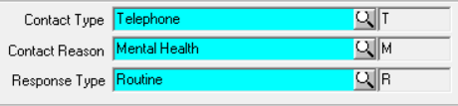
Note: Pay close attention to the Response Type selection. If the Response Type is not Routine, there are specific access time requirements.
Title 9 defines “Emergent (access w/in 1 hour)” as a condition in which the client, due to a mental disorder, is an imminent danger to self or others or is immediately unable to provide for or utilize food, shelter, or clothing. This situation indicates an immediate need for psychiatric inpatient hospitalization or psychiatric health facility services. Client must be seen within one (1) hour of initial client contact/ referral.
Title 9 defines “Urgent (access w/in 48 hours)” as a condition, which without timely intervention is certain to result in an immediate emergency psychiatric condition. Client must be seen within forty-eight (48) hours of initial client contact/referral.
When using the Response Type “D/C from IP (72 hour assess)” Patient Discharged from Inpatient Facility, be sure that the inquiry date reflects the actual discharge date and time of the client, not the date and time the hospital notifies the provider that the client is being discharged. Client must be seen within seventy-two (72) hours of discharge date.
When selecting Emergent, Urgent, or D/C from IP, ensure to adhere to the time requirements. To indicate urgency for clients who do not meet the Title 9 definition, use the Notes box or an internal tracking mechanism.
- Click on the magnifying glass.
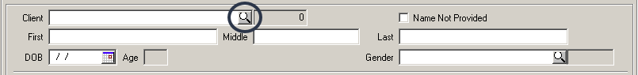

- Click the “All” radio button and search for the client; use the filter settings if helpful. If the client is in CCBH, select the client and click “OK.”
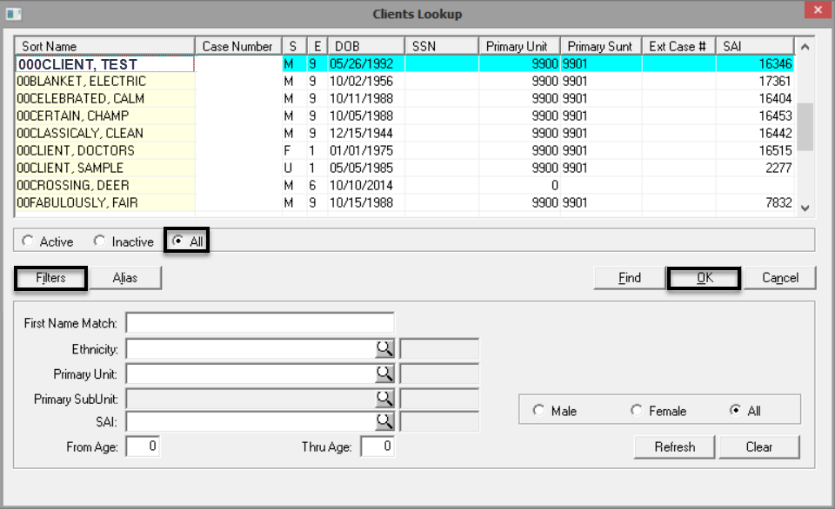
  - If the client is in CCBH, most of the demographic information will prepopulate from the most recent final approved Demographic Form. Strive to complete any blank fields.
  - If the client is not in CCBH, and he/she will be offered an appointment, the client must be added to CCBH before moving forward. After the Core Client Information is added and a case number is generated, input the case number in the “Client” field and press tab. Strive to complete any blank fields.
  - Never use the Name Not Provided check box and never type a client’s name via free text. A case number must always be present.
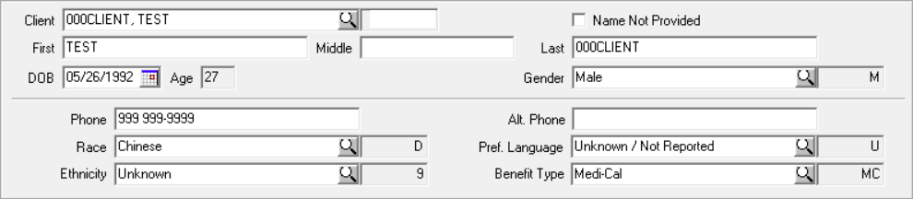
- Select Add in the service container.
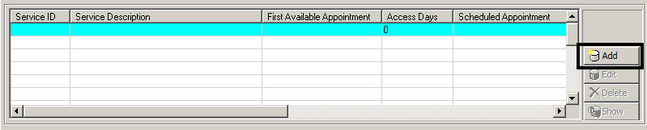
- Click on the magnifying glass and select the service. Enter the First Offered Appointment; it must be on or after the Date of Contact. Although Second Offered Appointment and Third Offered Appointment are not software required fields, dates must be entered in those fields for reporting purposes, even if the client accepts the first offered appointment. Enter the Second Offered Appointment; it must be after the First Offered Appointment. Enter the Third Offered Appointment; it must be after the Second Offered Appointment. If the client schedules an appointment, enter the date of the scheduled appointment. If an appointment was offered, but not accepted, leave Appointment Scheduled blank. Access days will be calculated between the Date of Contact and the First Offered Appointment. Click “Save”.
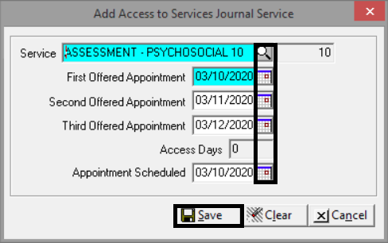
  - Service Code 10 - Assessment - Psychosocial is used for Mental Health Services.
  - Service Code 11 - Medication Evaluation is used for Psychiatric Services.
  - Service Code 30 - Individual Psychotherapy is used for the first treatment service, which is defined as the first appointment after medical necessity is determined.
If the treatment service appointment is offered and scheduled at the same time as the mental health/psychiatric appointment, add the three treatment service offered dates and appointment scheduled date in the same journal. If a program’s practice is to schedule the treatment service appointment after the client has attended the assessment appointment, final approve the first journal with the mental health/psychiatric appointment, and then later enter a second journal when a treatment service is scheduled.
- Enter the Disposition. Referred To is required unless the selected Disposition is Made Appointment. Referred From is always required.

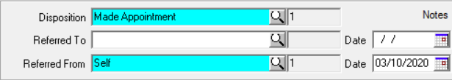

  - Made Appointment - Client was offered an appointment and scheduled an appointment.
  - Declined Appointment (Specify) - Client was offered an appointment, but did not schedule an appointment, and the call was terminated or the client walked out of the office without explanation before referrals were offered.
  - Referred Out - Location - Client called and was offered an appointment, but did not schedule an appointment because the client learned that the office was further away than anticipated and the client would prefer to receive services closer to his or her residence. If the client terminates the request for service due to location prior to an appointment being offered, no journal entry is required.
  - Referred Out - Required Other Services - Client was offered an appointment, but did not schedule an appointment because it was determined that the client would not be a fit for the program (example: client is an adult and the program serves the Child/Youth/Family population). If it is determined the client is not a fit to the program prior to an appointment being offered, no journal entry is required.
  - Referred Out - Wait Too Long - Client was offered an appointment, but did not schedule an appointment because he or she would prefer to be seen sooner elsewhere
  - Referred Out - Other (Specify) - Client was referred out for a reason not listed in the table. Specify the reason in the Notes box.
- Any access times over 10 days for Behavioral Health Assessments and over 15 days for Psychiatric Assessments must be addressed in Notes field. Indicate in the Notes field if the client/caregiver elects to wait beyond the aforementioned 10 or 15 days despite being offered a referral to another program. Any applicable comments may be documented in the Notes field.

- Click Final Approve. No signature/password is necessary.

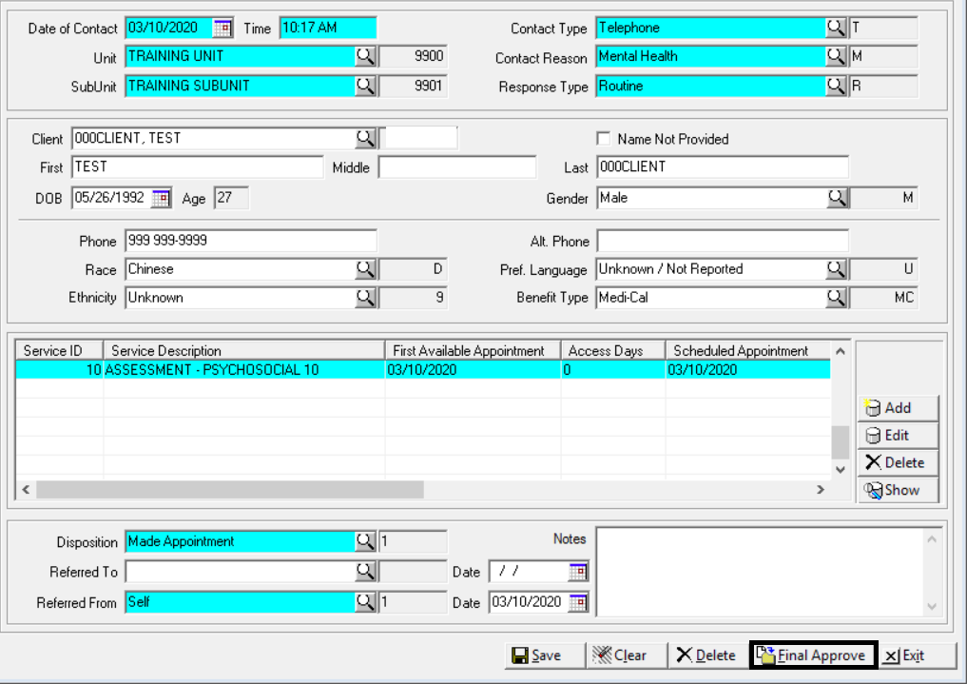

Please note: Clinical staff will continue to enter Access to Services information in the log. The Access to Services Log has been updated to match the CCBH Access to Services Journal and should be used by clinical staff who do not have access to the Journal. In the event of a system outage, programs should complete the Access to Services Log. Once programs are notified by the Optum Support Desk that the system has been restored, Access to Services Journal entry in CCBH can resume. Enter any log entries that were made during the outage into the Access to Services Journal in CCBH by the next business day.

